Proces

- We brush painted one piece af plexiglass with the GC50, let it cure nigtht over, 15 ours
- Rinsed it with acetone
- Marked up 3 fields
- One field sanded with 120 grid, one sanded with 240 grid, a one no sanding
- Wet layup two layers of 200g/sqm 3k twill
- Let it cure fro one week
- Cutted the 3 field out
- Removed the tree part form the plexiglas
- Then we bend each part 2 times over a one inch tube until it broke,

Conclusion… It is wery important to sand the GC50, otherwise it will delaminate. No visible difference between 120 and 240 grid sanding.

The result
No sanding, as you can see the gelcoat delaminate big time.
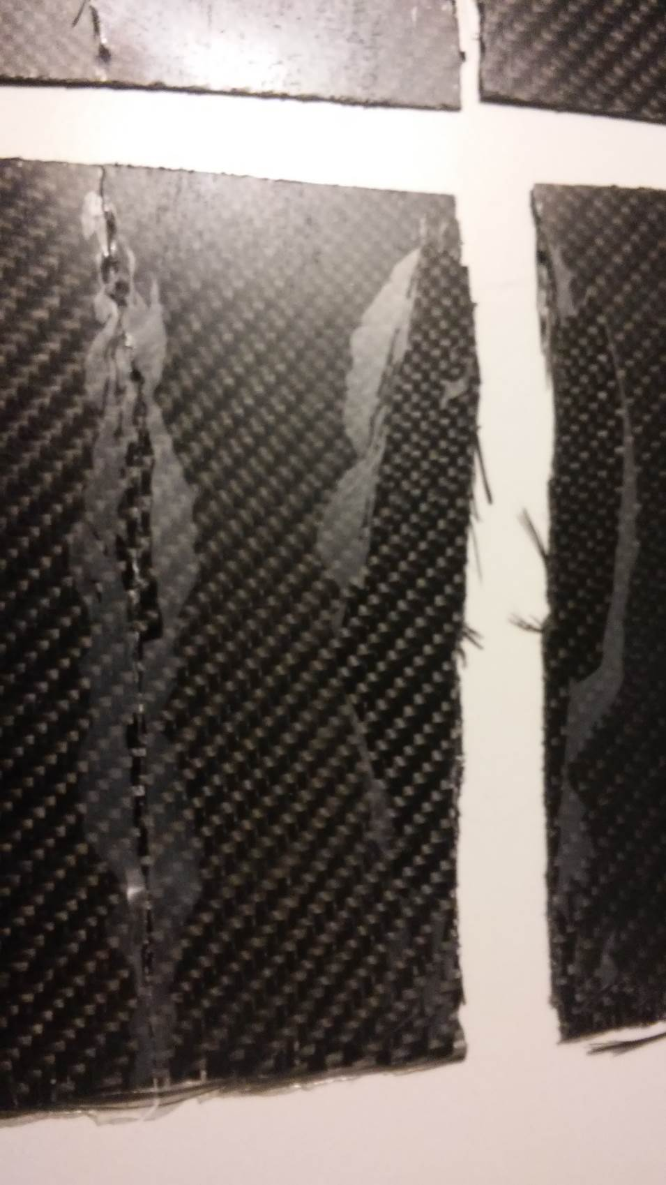
120 grid, No delamitaion at all
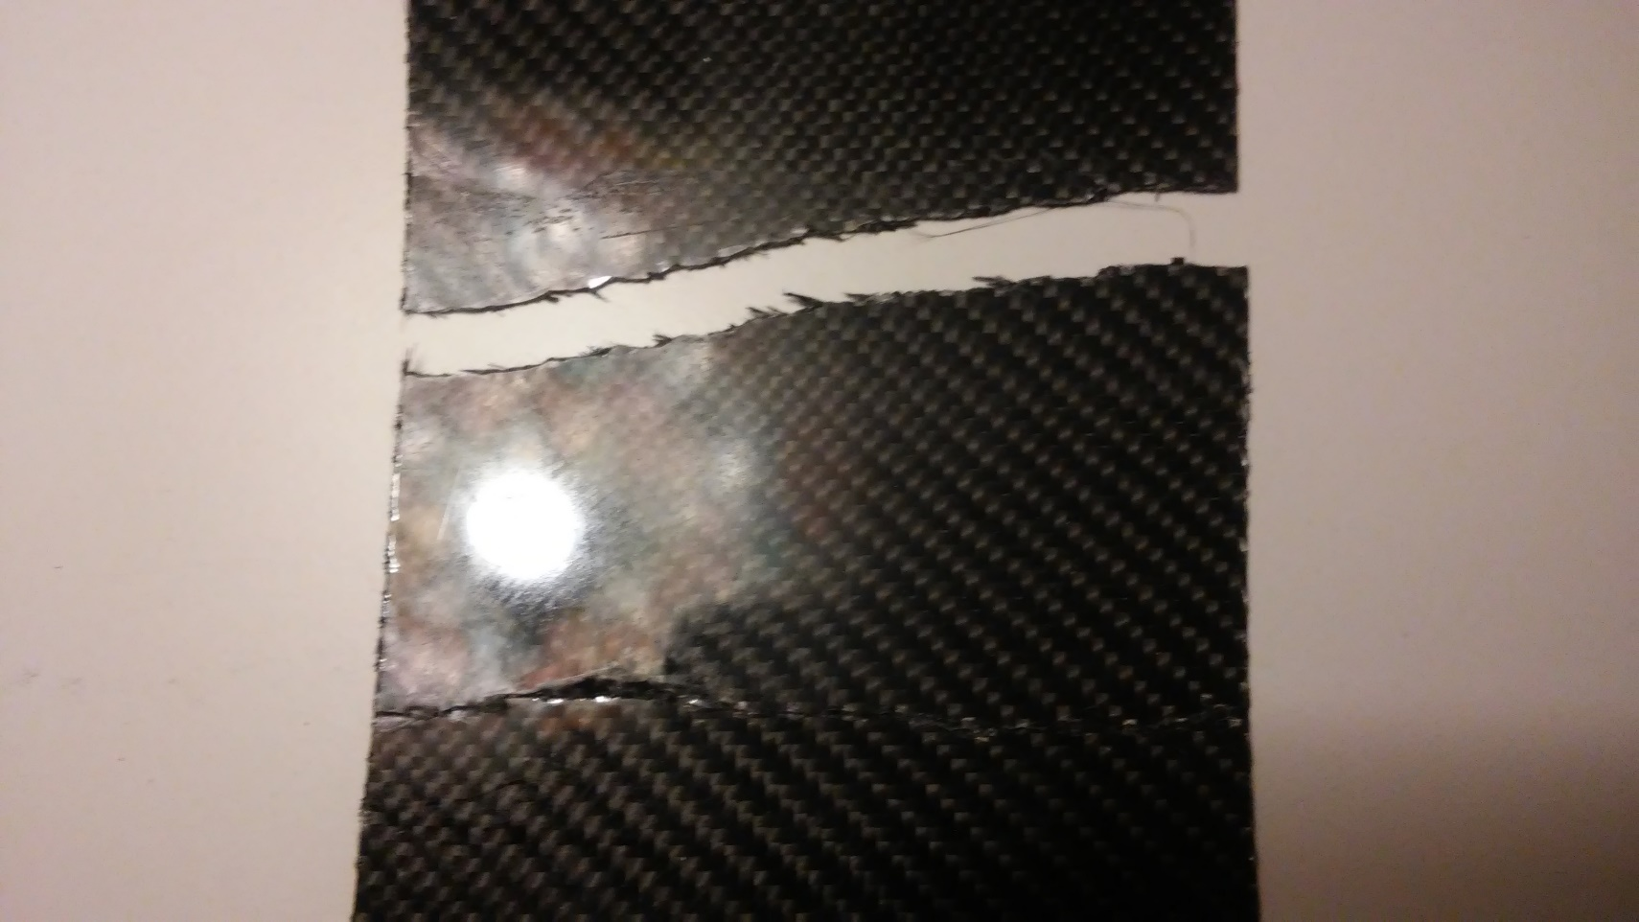
240 grid sanding, same as 120 grid sanding, no delamination.
